**Student Management System**

**A MINOR PROJECT REPORT**

**Submitted in partial fulfillment of the requirement for the award of Degree of IMCA**

**Submitted to**



**RAJIV GANDHI PRODYOGIKI VISHWAVIDYALAYA, BHOPAL (M.P.)**

**Submitted by:**

**Mr. Siddharth Jain**

**Enrollment No 0827CA21DD54**

**Under the Supervision of**

**Prof. Shruti Vijayvargiya**



**IMCA**

**ACROPOLIS INSTITUTE OF TECHONOLOGY & RESEARCH, INDORE**

**SESSION 2022-23**

# **Faculty of Computer Applications**

# **AITR, Indore**

# 

### BONAFIDE CERTIFICATE

This is to certify that Minor Project entitled **“Student Management System”** being submitted by **Mr. Siddharth Jain (0827CA21DD54)** for partial fulfillment of the requirement for the award of degree of **Integrated** **Master of Computer Applications** to **Rajiv Gandhi Proudyogiki Vishwavidyalaya, Bhopal (M.P.)** during the academic year 2022-23 is a record of bonafide piece of work, carried out by the student under my supervision and guidance in the **Faculty of Computer Applications, AITR, Indore.**

**(Supervisor) (Prof. Geeta Santhosh)**

Designation, AITR, Indore Professor & HOD, MCA

**(Internal Examiner) (External Examiner)**

**Date: Date:**

**Table of Contents**

|  |  |  |
| --- | --- | --- |
| S.No. | Content | Page No. |
| 1. | Title Page | 1 |
| 2. | Certificate | 2 |
| 3. | Table of Contents | 3 |
| 4. | Introduction/Objective Of Project | 4 |
| 5. | Module Description | 6 |
| 6. | Design/Flow Chart/ER Diagram | 8 |
| 7. | List of tables | 9 |
| 8. | Testing/Test Cases | 10 |
| 9. | Front End Forms | 11 |
| 10. | Report |  |
| 11. | Conclusion | 16 |
| 12. | Bibliography | 17 |

**Introduction/Objective of Project:**

**INTRODUCTION**

The Student Management System is a comprehensive software solution designed to streamline the management of student data in educational institutions. This project aims to provide a user-friendly interface for efficient CRUD (Create, Read, Update, Delete) operations on student records, along with a dashboard that highlights important statistics.

The dashboard feature of the Student Management System plays a crucial role in providing valuable insights and statistics related to student demographics and enrollment trends. It offers a visually appealing and interactive interface that showcases key information at a glance.

The dashboard highlights the number of male and female students, providing a gender distribution overview. This helps administrators and educators understand the gender balance within the student population and make informed decisions related to student support programs and resource allocation.

Additionally, the dashboard displays the number of students studying in each course, enabling stakeholders to track the popularity and demand for different programs. This information assists in curriculum planning, resource allocation, and identifying potential areas for program expansion.

Furthermore, the dashboard presents data on the number of students studying in each academic year, ranging from the 1st year to the final year. This provides insights into student retention rates, progression through the academic program, and overall student satisfaction.

**OBJECTIVE**

The primary objective of this project is to simplify the process of managing student information, reducing manual paperwork, and ensuring data accuracy. By centralizing student records and automating administrative tasks, the system aims to enhance efficiency and productivity in educational institutions.

The objective of this project is to create a robust and user-friendly system that simplifies student management processes, improves data accuracy, and provides valuable insights through a comprehensive dashboard. By automating routine tasks and centralizing student information, the system aims to enhance efficiency, productivity, and decision-making within educational institutions. It seeks to empower administrators, teachers, and students with a reliable and efficient tool for managing student data, enrollment processes, and monitoring academic progress. The intuitive dashboard further enriches the user experience by offering a visual representation of key statistics and trends, facilitating informed decision-making and strategic planning.

In summary, the dashboard feature of the Student Management System serves as a powerful tool for administrators and educators, providing valuable insights into student demographics, course popularity, and academic progression. It enhances decision-making capabilities, promotes transparency, and supports the efficient management of educational institutions.

**Module Description:**

1. Insert Module: The Insert module is responsible for adding new student records into the system. It provides a user-friendly interface where administrators or authorized users can enter the necessary details of a student, including their personal information, contact details, course enrollment, and year of admission. The module ensures data validation and integrity checks to maintain accurate records.
2. Dashboard Module: The Dashboard module serves as a central hub that provides a comprehensive overview of student-related data and statistics. It presents important information through a set of visually appealing cards. The dashboard displays key metrics, including the total number of male and female students, the number of students in each course, and the distribution of students across different academic years. These cards offer a quick glance at the essential statistics, enabling users to have an instant understanding of the student population.
3. View Module: The View module allows users to access and view the student data stored in the system. It provides a tabular representation of the student records, displaying information such as roll number, name, course, year of admission, and contact details. Users can apply filters, search for specific records, and sort the data based on different criteria to easily locate and retrieve the desired information.
4. Search Module: The Search module facilitates easy and quick retrieval of student records based on specific search criteria. Users can search for students by entering their roll number or name in the search field. The module then displays the matching results, allowing users to view the details of the desired student or group of students. This feature is especially useful when administrators or users need to quickly access specific student information without browsing through the entire student database.
5. Update Module: The Update module enables authorized users to modify and update the existing student records. It offers a convenient interface where administrators or designated personnel can make changes to student information, such as contact details, course enrollment, or any other relevant data. The module ensures data integrity by validating the inputs and ensuring that only authorized users can perform updates.
6. Delete Module: The Delete module allows authorized users to remove student records from the system. It provides a secure mechanism to permanently delete student data that is no longer required or relevant. Users can select specific records or apply filters to identify the records to be deleted. The module incorporates necessary safeguards and confirmation prompts to prevent accidental deletion of data.

The module-based structure of the Student Management System ensures a modular and scalable design, allowing for easy maintenance, updates, and future enhancements. Each module performs specific functions, contributing to the overall efficiency and effectiveness of managing student-related data within educational institutions.

**Design/Flow Chart/ER Diagram**



**List of tables**

**STUDENTS TABLE:**

**Description:**

The "Students" table includes the essential fields required to store student information in the Student Management System. These fields capture the student's unique identifier, name, father's name, contact details, gender, course details, year of admission, and date of birth. The table serves as the foundation for managing and organizing student data efficiently.

**Columns:**

1. RollNo: A unique identifier for each student.
2. FName: First name of the student.
3. LName: Last name of the student.
4. FatherName: Name of the student's father.
5. MobNo: Mobile number of the student.
6. AltMobNo: Alternate mobile number of the student.
7. Gender: Gender of the student (e.g., Male, Female).
8. Course: Course in which the student is enrolled.
9. YOA: Year of admission of the student.
10. DOB: Date of birth of the student.

**Testing/Test Cases**

|  |  |  |  |  |  |
| --- | --- | --- | --- | --- | --- |
| **Test Case** | **Test Condition** | **Test Input** | **Expected Result** | **Test Input** | **Test Result** |
| 1 | Inserting a New Student | Valid student data | New student is successfully inserted into the database | RollNo: 101, FName: Rahul, LName: Sharma, FatherName: Shyam, MobNo: 1234567890, AltMobNo: 9876543210, Gender: Male, Course: BCA, YOA: 2022, DOB: 01/01/2000 | Passed |
| 2 | Updating Student Details | Existing student data | Student details are successfully updated in the database | RollNo: 101, FName: Rahul, LName: Sharma, MobNo: 9876543210 | Passed |
| 3 | Deleting a Student Record | Existing student data | Student record is successfully deleted from the database | RollNo: 101 | Passed |
| 4 | Searching for a Student | Valid search criteria | Student matching the search criteria is displayed | RollNo: 101 | Passed |
| 5 | Validation of Mandatory Fields | Missing mandatory field(s) | Appropriate error message(s) are displayed | FName: Rahul, LName: Sharma, Course: (blank) | Passed |

**Front End Forms**

1. **DASHBOARD FORM:** 
   1. **Form Description:**

The Dashboard Form serves as the main interface of the application, providing an overview of key statistics and data related to student management.

* 1. **Fields/Components:**
     1. Title Label: Displays the title of the form as "Dashboard".
     2. Total Students Card: Shows the total number of students in the database.
     3. Male Students Card: Displays the count of male students in the database.
     4. Female Students Card: Displays the count of female students in the database.
     5. BCA Students Card: Shows the count of students enrolled in the BCA course.
     6. MCA Students Card: Shows the count of students enrolled in the MCA course.
     7. IIMCA Students Card: Displays the count of students enrolled in the IIMCA course.

1. **INSERT FORM:**
   1. **Form Description:**

The Insert Form allows users to add new student records to the database.

* 1. **Fields/Components:**
     1. Roll Number (Text Field): For entering the roll number of the student.
     2. First Name (Text Field): For entering the first name of the student.
     3. Last Name (Text Field): For entering the last name of the student.
     4. Father's Name (Text Field): For entering the father's name of the student.
     5. Mobile Number (Text Field): For entering the mobile number of the student.
     6. Alternate Mobile Number (Text Field): For entering an alternate mobile number of the student.
     7. Gender (Dropdown List): For selecting the gender of the student.
     8. Course (Dropdown List): For selecting the course of the student.
     9. Year of Admission (Automatically Calculated): Based on the current year.
     10. Date of Birth (Date Picker): For selecting the date of birth of the student.
     11. Save Button: To submit the data and add the new student record to the database.

1. **View Form:**
   1. **Form Description:**

The View Form displays a tabular representation of all student records stored in the database.

* 1. **Fields/Components:**
     1. Search Field (Text Field): For searching students by roll number or name.
     2. Student Table (DataGridView): Showing all student records with columns for roll number, name, gender, course, year of admission, and other details.
     3. Update Button: To open the Update Form for modifying the selected student record.
     4. Delete Button: To delete the selected student record.

1. **Update Form:** 
   1. **Form Description:**

The Update Form allows users to modify the details of an existing student record.

* 1. **Fields/Components:**
     1. Roll Number (Read-only Text Field): Displaying the roll number of the student (cannot be modified).
     2. First Name (Text Field): For editing the first name of the student.
     3. Last Name (Text Field): For editing the last name of the student.
     4. Father's Name (Text Field): For editing the father's name of the student.
     5. Mobile Number (Text Field): For editing the mobile number of the student.
     6. Alternate Mobile Number (Text Field): For editing the alternate mobile number of the student.
     7. Gender (Dropdown List): For selecting/editing the gender of the student.
     8. Course (Dropdown List): For selecting/editing the course of the student.
     9. Year of Admission (Read-only Text Field): Displaying the year of admission (cannot be modified).
     10. Date of Birth (Date Picker): For selecting/editing the date of birth of the student.
     11. Update Button: To save the modified data and update the student record.

**Outputs**

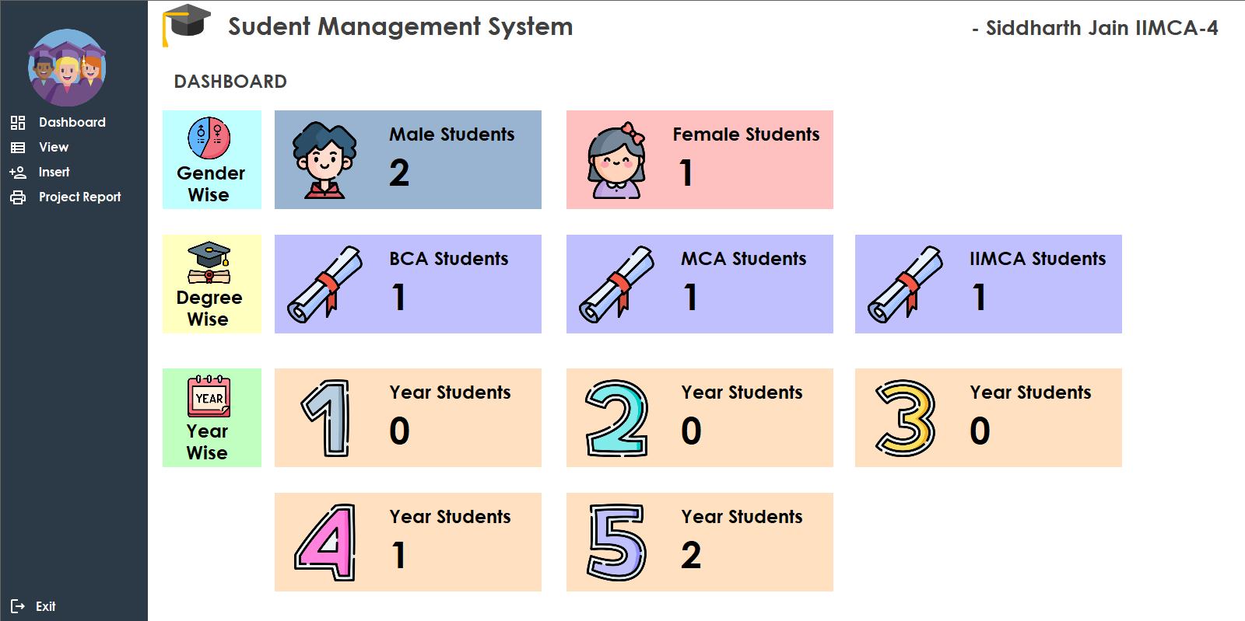

Dashboard

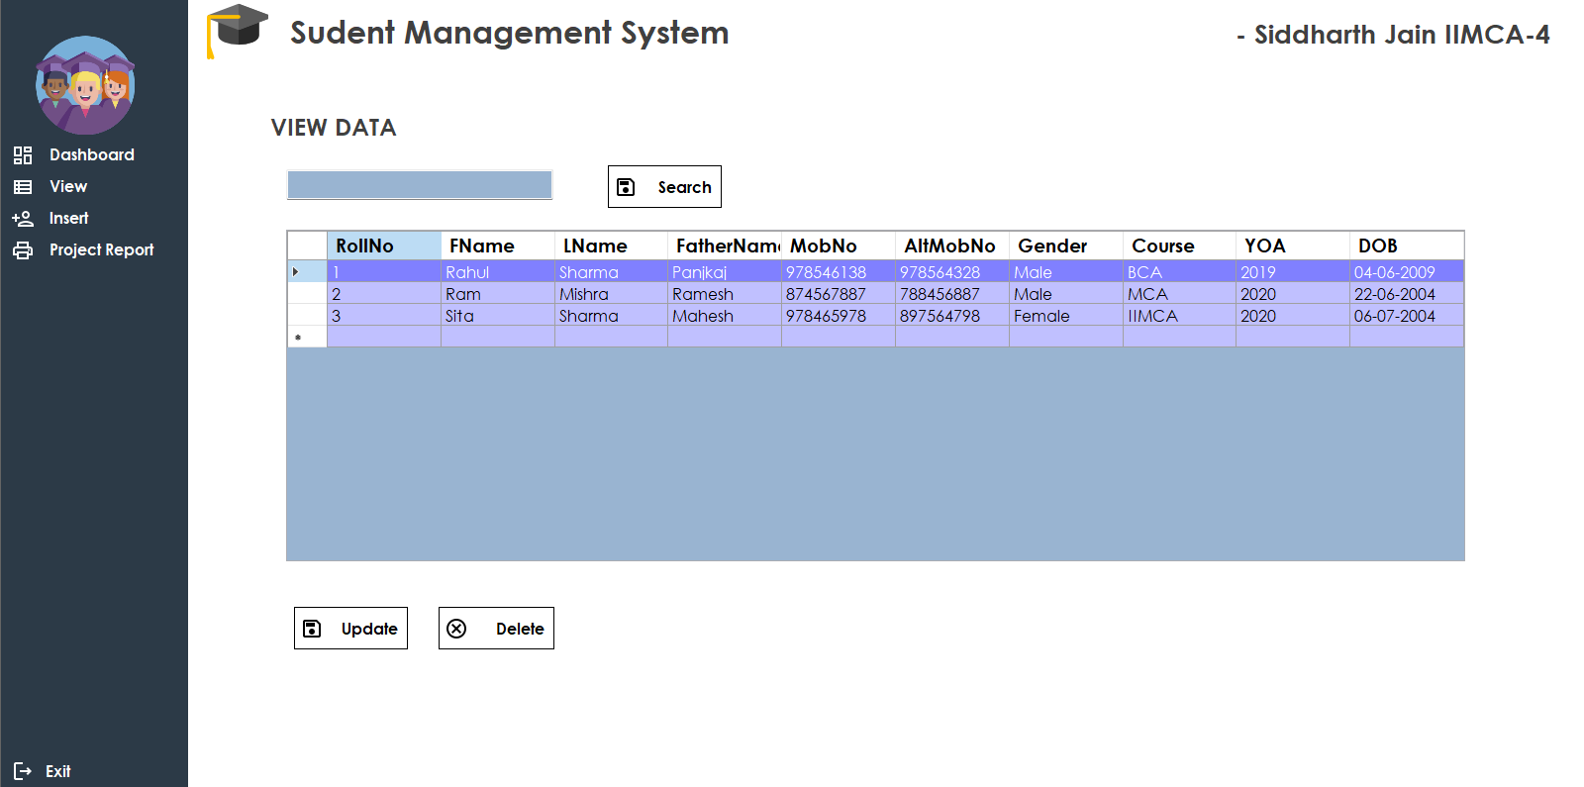

View

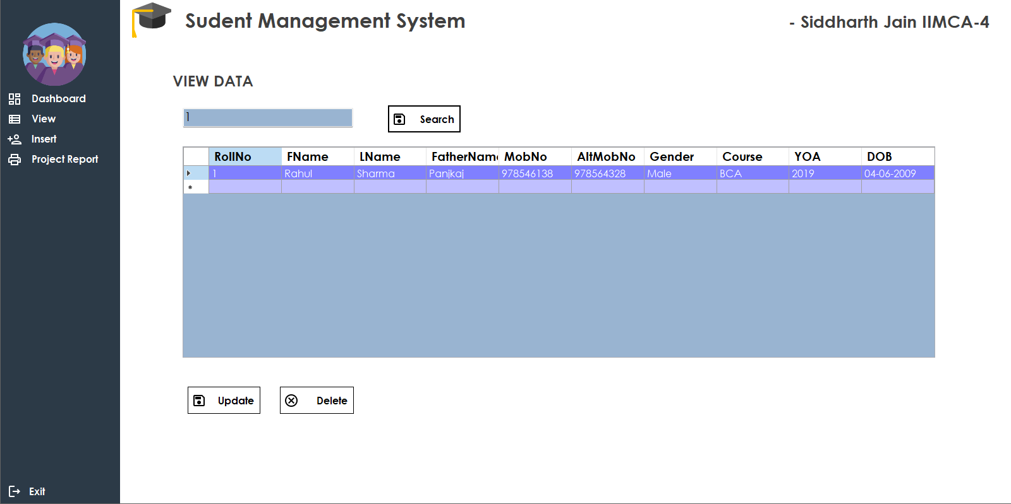

Search

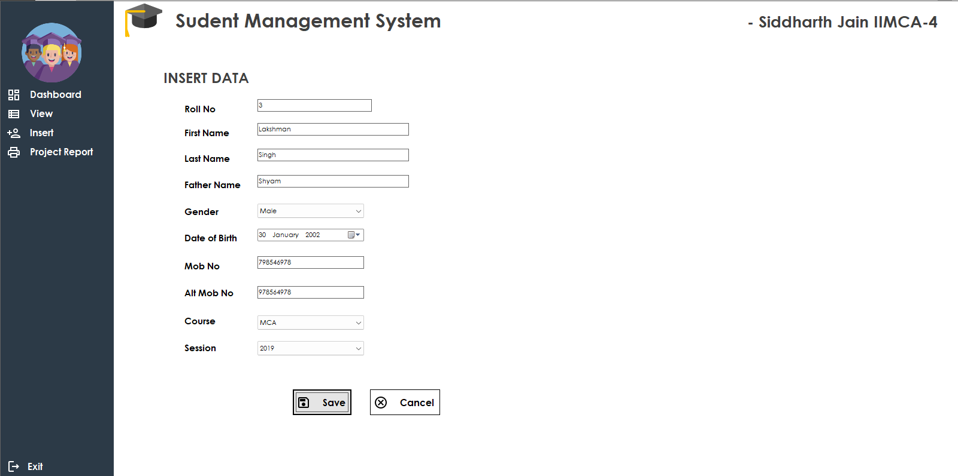

Insert

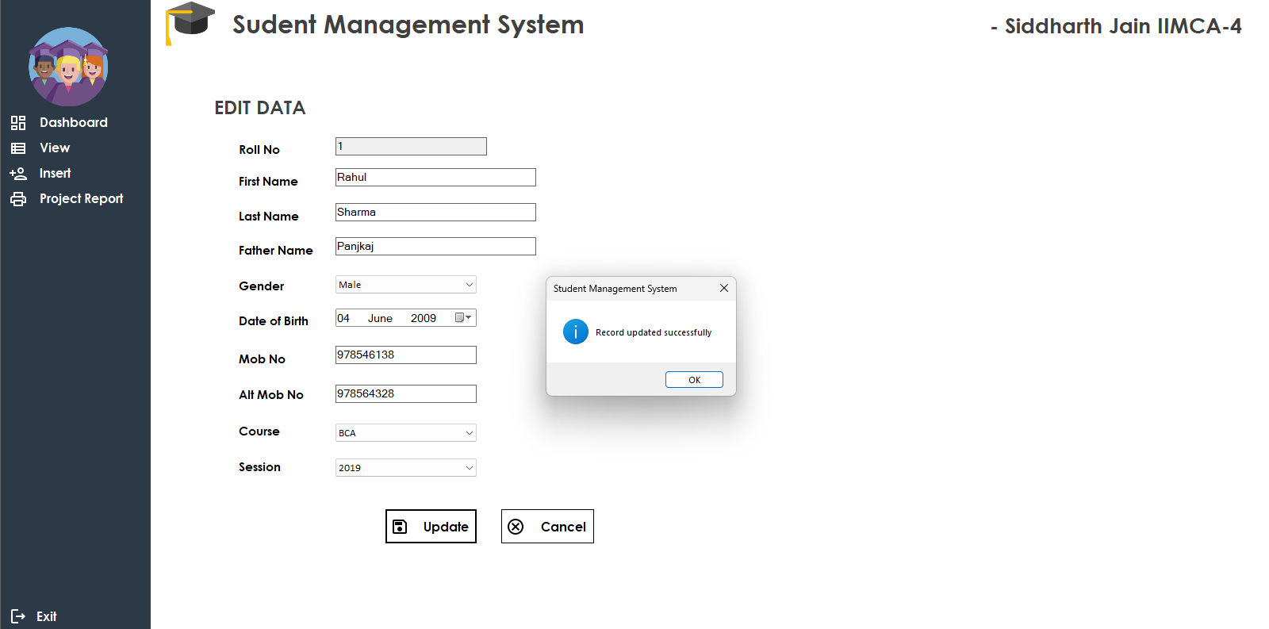

Update

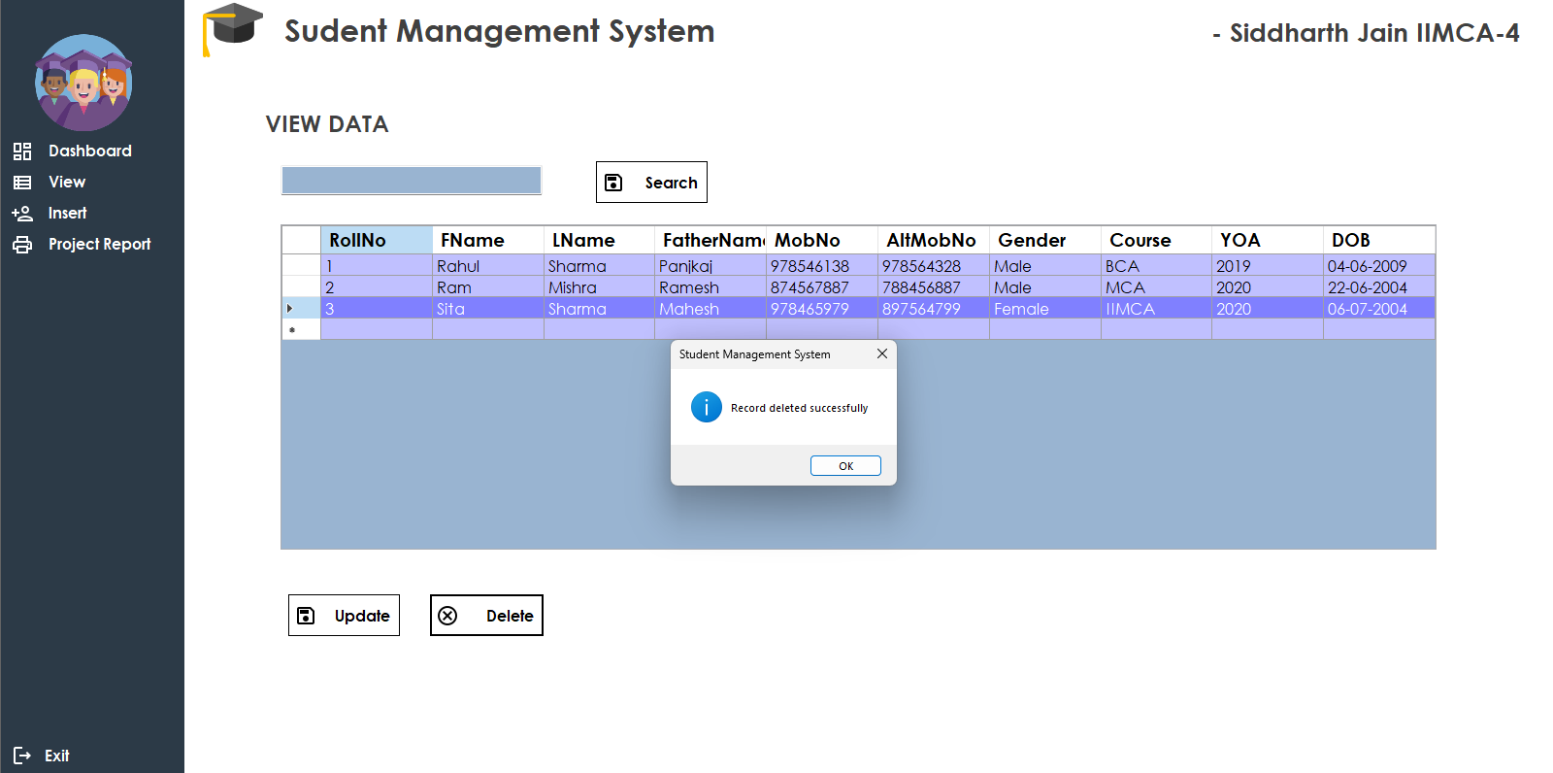

Delete

**Conclusion**

The Student Management System project has successfully achieved its objectives of efficient student data management and streamlined processes. Through the implementation of various modules and functionalities, the system has provided a user-friendly interface for managing student records, performing CRUD operations, and generating insightful reports.

During the development and testing phases, we encountered and addressed several challenges, ensuring the system's functionality and reliability. The feedback received from users during the evaluation phase has been invaluable in making improvements and enhancements to the system, resulting in a more user-centric and efficient solution.

The Student Management System has proven to be an effective tool for educational institutions, enabling them to maintain accurate student information, monitor student enrollment and progress, and generate meaningful reports. The system's dashboard provides a comprehensive overview of key statistics, such as the number of male and female students, the distribution of students across courses, and the count of students in each academic year.

Overall, the implementation of the Student Management System has yielded positive results, simplifying administrative tasks, improving data accuracy, and enhancing decision-making processes. The system has demonstrated its potential for further expansion and customization, allowing for additional features and functionalities to be integrated in the future.

In conclusion, the Student Management System has emerged as a valuable asset for educational institutions, contributing to efficient student data management, improved workflow, and enhanced user experience. With the continued support and feedback from users, the system can be further enhanced to meet evolving needs and serve as a cornerstone for effective student administration.

**Bibliography**

During the development of the Student Management System project, the following resources were referenced and utilized:

1. **WEBSITES**
   1. <https://chat.openai.com/>
   2. <https://stackoverflow.com/>
   3. <https://www.youtube.com/>
   4. <https://www.canva.com/>
   5. <https://feathericons.com/>
   6. <https://fonts.google.com/icons>
   7. <https://www.freepik.com/>
   8. <https://fontawesome.com/>
2. **APPLICATIONS**
   1. Visual Studio 2022